# Prototype Plan

The purpose of the rapid prototype in this project is to validate models and validate claims made by COTS products. The prototype will also be used to

## Iteration 1 : RF transmitting and receiving

Testing of received signal strength in different environments to simulate an oil rig. This test will then be used to analyse the claims made by COTS products. This iteration will also be used to analyse the path loss models as described in

<https://drive.google.com/open?id=1eTW31K58iL9IMQgo1sBdHNjTFcR5FB6I>

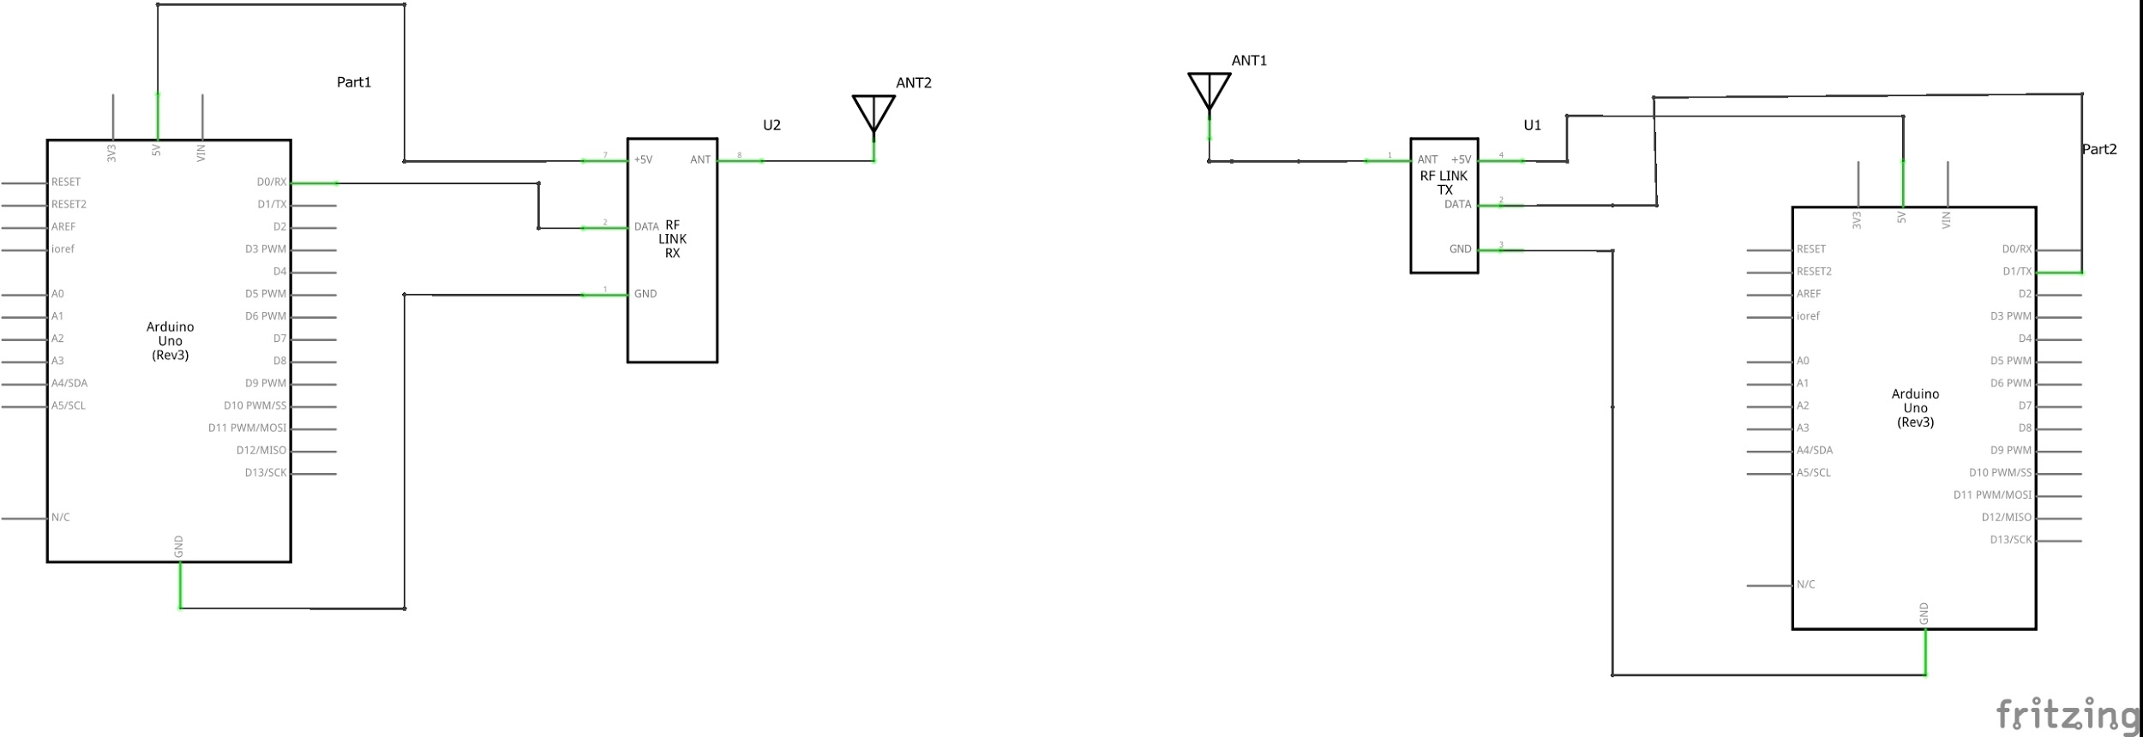

In this iteration the two arduinos and the wireless transmitters and receivers will be used. The system can also use path loss model to determine the distance from the transmitter to the receiver.

## Iteration 2 : Accelerometer

Adding an accelerometer to the system as a way to detect a falling worker. The with this iteration is to add the accelerometer to the transmitter to compliment the distance tracking.

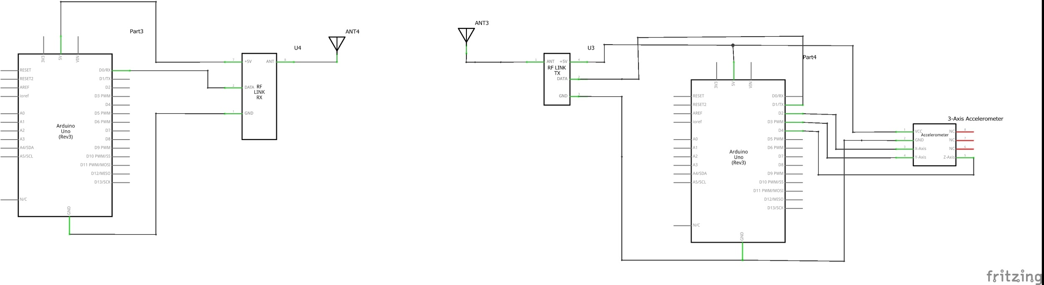

## Iteration 3: Water Sensor

Adding a water sensor to determine if a worker has fallen into the ocean. The concept behind this iteration is that if the water sensor detects water after the accelerometer has detected a fall then the transmitter will send an alert to the network.

